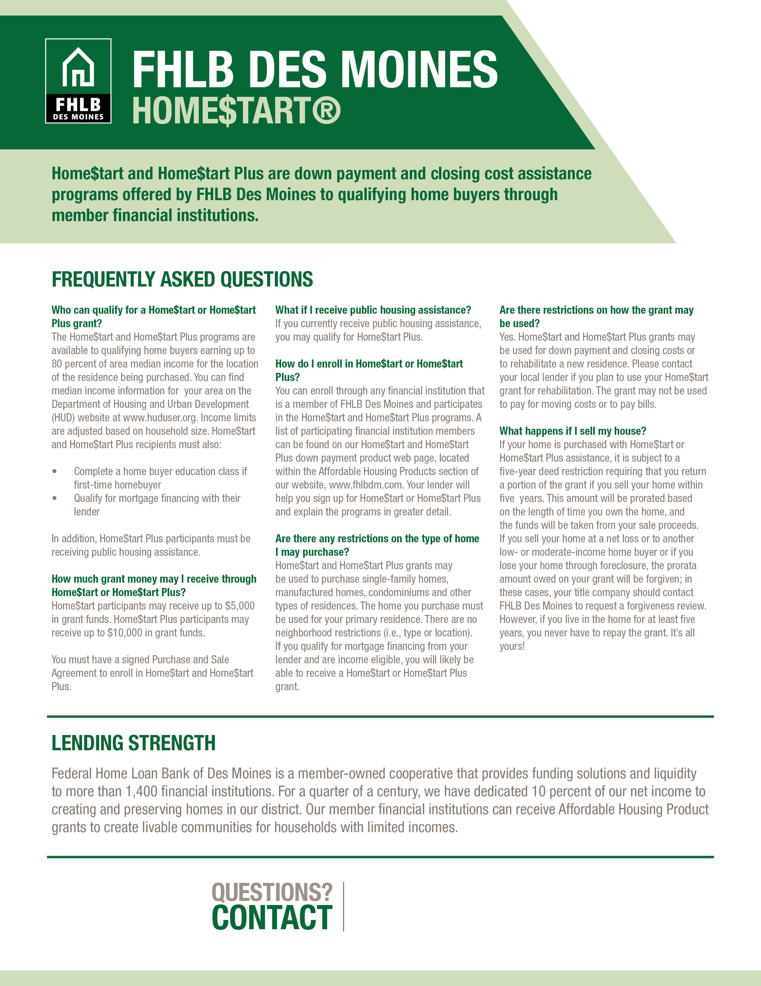

**Conservation Employees’ Credit Union**

**888.897.2323**

**cecuonline.org**

